Date: 11-07-22

Author: Alex Hsia

**Stakeholders**: Steven Pyke, Bo Williams, Personalization Team

**Data Engineers**: Vincent Thomas, Zachary Lancaster

**Tableau Admin:** Kevin McLaughlin

**Purpose:** The business review Tableau dashboard is used to monitor key metrics for Wayfinder Personalization products such as Your CNN, Watch Next Videos, and Related Articles.

**Metrics and SQL definitions:** [Paperdoc Link](https://paper.dropbox.com/doc/Business-Review-Metrics-Documentation--Bsj~kmeKcFjMihAmOYkdqVqcAg-cENhx3cBGIpu0sxBM97uC)

All metrics are pulled from Snowflake Zion data using enriched tables to easily access certain parameters for mobile app. The 4 main tables used are:

Pageview → Any pageview that fires will log a pageview, even a settings page. Articles will also fire pageviews. Opening up the app will have a page view.

Component On → This table logs all what the user sees on their mobile app screen. You can think of this table as impressions. If a user is on Your CNN tab, and scrolls through different article cards, it will be logged. If a user clicks on an article, component on will log what paragraph a user is on, how far a user scrolled, etc.

Generic_Taps → This table logs what a user taps on or clicks on.

Video_Content_Started → This table logs when a video has started, but does not log how long a video played for.

Video_Content_Playing → This table logs how long a user played a video for

**Production Tables:** There are two tables where this data resides.

The first is going to an analytics database and the personalization schema. The second is a view in the Analytics_tools db and DI_Tableau_prod schema. The data has to be in the DI_Tableau_Prod schema so Tableau can connect to it. It is the only database/schema Tableau can connect to.

Main: "ANALYTICS"."PERSONALIZATION"."WEEKLY_BUSINESS_REVIEW"

View: "ANALYTIC_TOOLS"."DI_TABLEAU_PROD"."WEEKLY_BUSINESS_REVIEW"

**Tableau:** There are 4 dashboards in total. The Overview dashboard provides high level metrics of personalization metrics. Your CNN, Watch Next, and Related Articles have their own detailed dashboards.

**Overview Dashboard:** [Link](https://tableau.east.warnermedia.com/#/site/CNN/views/PersonalizationBusinessReview/OverviewDash)

**Your CNN Dashboard:** [Link](https://tableau.east.warnermedia.com/#/site/CNN/views/PersonalizationBusinessReview/YourCNNDash)

**Watch Next Dashboard**: [Link](https://tableau.east.warnermedia.com/#/site/CNN/views/PersonalizationBusinessReview/WatchNextDash)

**Related Articles Dashboard:** [Link](https://tableau.east.warnermedia.com/#/site/CNN/views/PersonalizationBusinessReview/RelatedArticlesDash)

**How to Update SQL:** All updates are done by Git. I personally use VS Studio. Screenshot:

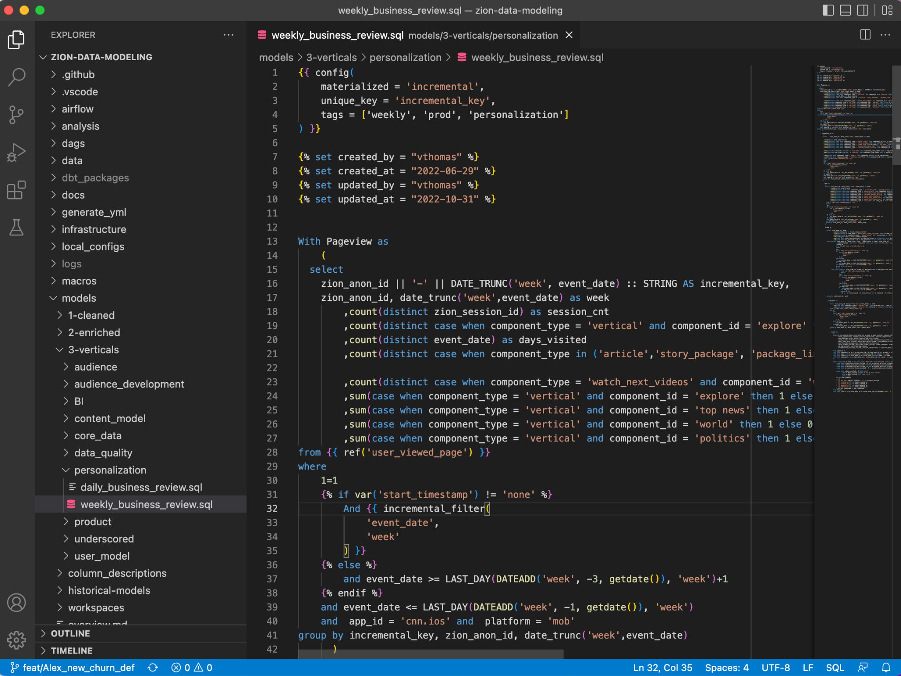

1. Clone the repo: https://github.com/turnercode/zion-data-modeling
2. Go to models → 3-Verticals → Personalization → weekly_business_review.sql
3. Create your own branch. Branch Naming Conventions:
   1. FEAT for features. /feat/Alex_Churn_filter
   2. FIX for fixes. /fix/Alex_churn_update
   3. Release is the main production branch
4. Commit, give a brief message of the changes
5. Publish Branch.

**Tableau:**

1. Always download the latest workbook from Tableau Server and make changes from there.
2. Give the updated workbook to Kevin M. to publish to the server.